# Dynamic Model Cell Requirements

Patch clamp amplifiers are typically supplied with a *model cell.* This is essentially an RC circuit with R and C values typical for a real cell (Fig 1A). The model cell can be attached to the head stage of the amplifier and used for testing amplifier and acquisition configuration and for training. A dynamic clamp system has more onerous testing and training requirements and would benefit from having a model cell with voltage activated conductances similar to those found in real cells – a *dynamic model cell* (MDC) (Fig 1B). The MDC can provide one or more active conductances, for example a sodium conductance, noise, leak. These can be controlled from a host to reproduce a number of biological artefacts.

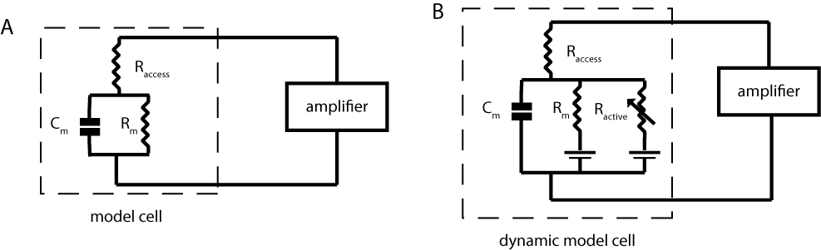

Figure . Circuit diagrams for *A)* normal and *B)* dynamic model cells. Typical values for components are Raccess=5MΩ, Rm=250MΩ, Cm=20pF and Ractive=5-∞MΩ, voltage across the model is ±100mV.

The requirements of the DMC are

* 1 digital to analogue and 1 analogue to digital channel of 100K sps @ 12 bit (These need more clarification).
* Computation requirements per sample similar to the DC.
* Model download, configuration and data upload to host PC.
* Easy programming environment with good IDE. This probably means a microprocessor rather than an FPGA and probably embedded linux or java.
* cheap